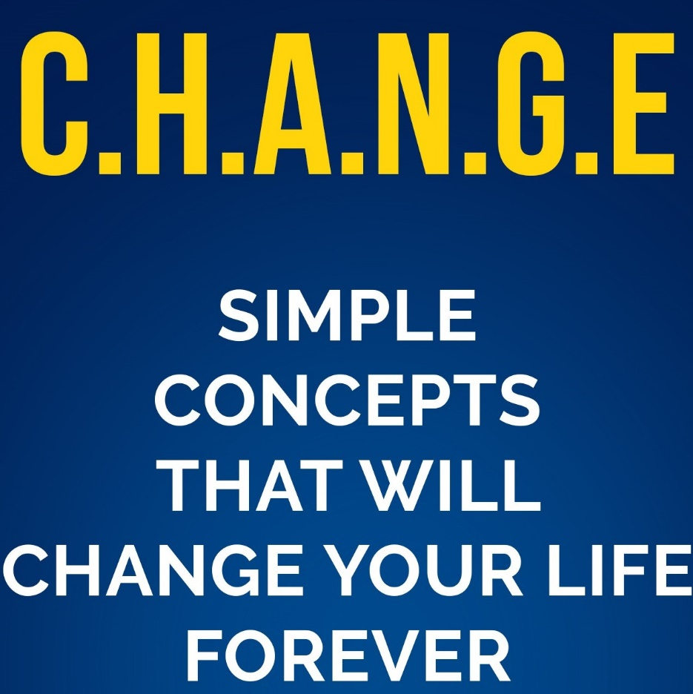

[**Website**](http://www.bradyoungchange.com) **Buy the Book and Receive a Free Consultation**

[**Podcast**](https://open.spotify.com/show/59baAI5LAm2Sd75HmcyyQG)

**The CHANGE Podcast is in the top 2% globally and acquiring new listeners every day. Follow the link above to listen to the podcast.**

**CHANGE Personal Workbook**

The CHANGE Program is simply easy to use program that will make a significant impact on your life. This workbook has questions that you need to answer now and then again after you read the book to see how your answers will differ. You will communicate better with your internal self and external world. You will develop more productive habits, form a more positive attitude, along with review your network of people you associate with. The program then goes on to assist you in accomplishing achievable goals and finally improve your level of education by understanding a few simple principals. This workbook is a preview of the book and gives you an idea of the topics and questions you will be asked during your journey. Your answers will CHANGE over the course of the program and hopefully, you will see significant personal growth upon completion of the program.

**Communication** is the first principal of the program. The messages you tell yourself and the messages you tell the world based on the ACTIONS you take.

After reading the section on communication answer the following questions.

1. What am I communicating to myself that is limiting my personal success?
2. Is the story I am telling myself limiting me or my business potential?

Yes or No

1. What ACTION am I taking to improve my communication skills?
2. Am I telling myself self-limiting beliefs? Yes or No
3. If so, why am I doing this?
4. What excuses am I giving myself as an out, so I can keep doing the things that I am doing and getting the same results?
5. What costs am I paying for not communicating effectively?
6. What am I communicating in my organization that is limiting my success?
7. What am I communicating to others that are hurting a real perception of myself?
8. What am I communicating to others that is limiting the perception of my business or professional life?
9. What are the costs for me to communicate an accurate portrait of myself to the world?
10. What are the costs if you do not?
11. What is your plan going forward to improve this area of your personal and professional life?

**When you answer the previous questions, you understand there is no excuse for not striving to improve your internal and external communication. By now you understand the value of positive communication and the costs of negative communication and have a plan to implement CHANGE in this area.**

**Chapter 2**

**Habits** can be defined as an acquired mode of behavior that has become nearly or completely involuntary. It takes 21 days to form a habit, so forming positive habits should be easy, right? Not so fast, negative habits are why we are the most obese least active nation on the planet. So, we must form a plan to implement CHANGE. We review the costs of just eating out in the book at 1 time a day along with the health costs of eating this way and then not exercising. Now it is time for a plan, it is time to take ACTION.

What are the habits that you want to form? Write them down in the section below.

1. ____________________________________________
2. ____________________________________________
3. ____________________________________________
4. ____________________________________________
5. ____________________________________________
6. ____________________________________________
7. ____________________________________________
8. ____________________________________________
9. ____________________________________________
10. ____________________________________________

What is your 21-day plan to CHANGE your habits? There is space on the next page to write out this plan.

1. How are you going to implement this plan?
2. If you fail one day are you going to quit or stick with your plan?
3. It is easier to quit than to keep going, remember that.
4. Is that cheeseburger worth the time in the ER thinking you are going to die?
5. Are you going to spend more time exercising or more time watching others exercise?
6. Are you going to find tools that will help improve your habits or make excuses?
7. Are you going to take your lunch and save the $20k and use the money for something worthwhile?
8. Are you going to quit drinking alcohol every night and maybe read something positive instead?
9. Are you going to be like the couple in the commercial and spend your money eating out or buy the house or take the vacation your desire?
10. Are you going to talk more about ideas and less about people?

Use the space below to write down a plan of action.

**Chapter 3**

**Attitude** is defined as a mental position or personal emotion toward a state of being or a fact. This basically states that attitude is a state of mind or position that a person can control. The point of the information presented earlier in the book basically just states the control of your attitude. When you look at the following questions keep in mind it is simple to be mindful and control our attitude if we desire to. People say that is just the way I am and that is not true. That is the way you want to be or you would CHANGE.

1. Do you generally have a positive outlook? Yes or No
2. If not, why do we not have a positive outlook? Write in the space below.
3. How is your attitude altered when faced with significant CHANGE either personally or professionally?
4. Why does this change occur?
5. Do you allow others to affect your attitude during these periods of change or is this an internal mechanism?
6. Does your attitude create problems in your life even as things as small as weight gain or is it the attitudes of others that create problems in your life?
7. Do you suffer from significant amounts of stress that create major problems in your life such as health issues from stress?
8. How will you manage your attitude going forward?

6. Does your attitude create problems in your life even as things as small as weight gain or is it the attitudes of others that create problems in your life?

1. Do you suffer from significant amounts of stress that create major problems in your life such as health issues from stress? Yes or No

7. Are you fully committed to your personal life, business, and activities?

A. If you are not fully committed to any aspect, do you feel it is fair to cheat other aspects of your life?

8. What will you do to regain commitment to the necessary aspects of your life?

9. Are you self-disciplined enough to control your attitude??

A. What steps can you take to improve your self-discipline?

10. How will you manage your attitude going forward?

Chapter 4

**Network** is an interconnected group of people that consist of business and personal contacts. Your network is one of the foundational ideas in the CHANGE Program because your network should grow and expand over time. Your network has a direct influence on you and your opinions, habits, attitudes, communication skills, goals, and can even show your level of education.

1. Outside of friends and close family who consists of my personal network?
2. What is the level of education of my network?
3. What place in life is my network? Are they headed in a positive direction or should I reconsider who I spend my time with?
4. Are people in your network growth-oriented regarding reading and personal growth? Yes or No
5. When posed with a question do people in your network look for peer-reviewed articles to back up any information they may question, or do they just repeat what they watched on their favorite network?
6. Are the people in your network helping to build you up or bring you down?

**Chaper 5**

**Goals** are desired results that are set to occur in the future. Goals are a foundation of the CHANGE Program because you cannot change without goals. Please spend some time on these because they are the foundation of CHANGE.

**Define Short Term Goals**

1. **____________________________________**
2. **____________________________________**
3. **____________________________________**
4. **____________________________________**
5. **_____________________________________**

**Define Long Term Goals**

1. **_____________________________________**
2. **_____________________________________**
3. **_____________________________________**
4. **_____________________________________**
5. **______________________________________**

**Here is more space if needed to write down your goals because you will need to refine your goals to make sure they accurately depicted. What is your plan to achieve these goals?**

**Chapter 6**

**Education** is something we all need because we are born completely ignorant, so we must learn to do even the most basic activities. Education is something we attain in phases of our lives at first by going to school and after we get out of high school education is choice. Adults engage in self-directed learning which is learning that an adult believes is worth the sacrifice from a theoretical or practical perspective. Please answer the following questions.

**Questions**

1. Adults engage in learning that is life centered and self-directed, what learning activity have you participated in the last 12 months?
2. If so, what was the activity you participated in?
3. Why did you undertake this learning activity?
4. How did the activity make you feel once you completed it?
5. How many books have you read in the last 12 months? Audiobooks count as books read and please include eBooks. ___
6. Did you keep track of the books you read or listened to with notes or use of a tool so you can review your notes later?
7. If the answer is no books in the last 12 months, why have you not read any books?
8. Now that you have a greater understanding of what a peer-reviewed article is, will this change your approach to making sure you the information you seek is from a reliable source that is backed by research?
9. If your answer is no, why do you feel this way?
10. What do you believe your IQ is?
11. Find a website and take an IQ test and make sure you research where you rank.
12. Where your IQ results higher or lower than you guessed?
13. What is your learning style?
14. If you do not know please take an online assessment to find out this information.

**The next step is to read the book and then come back and review your answers to the questions in this workbook.**